**DMC**

**DATE: 14 December 2018**

**TIME: 12:30 – 16:45**

**ATTENDEES** Tom Gibbs, Elliot Chester, Henry Crofts

***COMMON ROOM***

**Sprint Aims:**

* **Review work completed from previous sprint tasks**
* **Confirm update work is reflective of what client requested in their feedback following the most recent presentation**
* **Review project timeline and development plan, assign tasks and negotiate completion times**
* **Reimport and scale all AR event sequences to ensure compatibility with posters and each other**
* **Playtest application to test robustness of application functionality**

**Meeting Minutes:**

All team in attendance. Studio-jam started.

Team analyzed playtest feedback which has already been gathered this sprint. So far feedback received points to initial confusion surrounding the user progress on the collection screen.

Users pointed out that they are unsure what the collection screen panels correspond to. Team believe that after a single unlock, the interaction between panels/application mascot appearance, is clear though can see the confusion for new users.

Team will replace the grey-scale panel images with overlaid padlocks, with the aim of the associated affordances telling the player this is an objective yet to be discovered.

Team will test the new design’s success in the next playtesting round.

Team moved onto the sprint’s primary focus of reimporting all AR sequences.

Team quickly realized that each member amending the same game scene was causing merge conflicts.

Team instead decided to work together on a single machine, through each AR sequence – the creator responsible for initial creation of the current event providing direction and explanation of how the event should function.

Team moved through all 8 AR sequences, before moving onto the information screen contents and repeating the process.

Team worked together to create new prefabs, re-make object animations and timings of almost all events.

Team are satisfied with quality, proportions and function of sequences amended so far.

Outstanding sequences not able to be completed within jam time:

* Inclement weather
* Homecoming

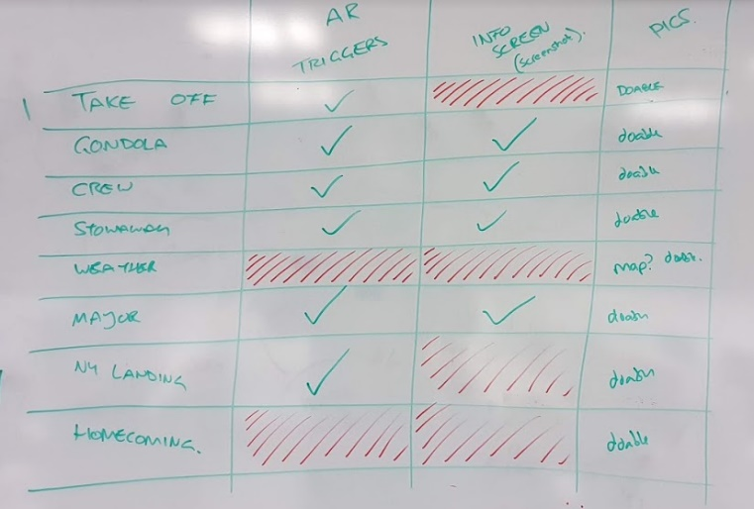

Remainder of tasks will be completed independently.

Team agreed that as playtesting tasks have not been fully completed these will be resolved over the weekend and the sprint kept open until the task to resolve issues identified in playtesting.

Tom will close the sprint during the next jam when fixed, then populate new tasks.

Team looked ahead to the following sprint’s work which needs to be completed in the following sprint, agreeing that team need to meet ahead of the presentation to create our presentation material for the client. Team will create a recorded walkthrough of the game, print poster designs for demonstration to the client and print necessary material from development plan to aide with explanation.

Team will meet on Monday to review the completion of outstanding AR event sequences/Information screen sequences and to create a recorded walkthrough of the games functionality, then begin preparation of the final module presentation.

Next meeting arranged for Monday 17 December @ 13:00.

**Tasks for the current week:**

* **ALL TEAM MEMBERS (6h)**

**AR EVENT TASK TO BE COMPLETED AS PART OF SCHEDULED JAM**

* **Playtest the application with a minimum of 10 users to confirm robust functionality (2h)**

(Team does not have access to test application with sufficient number of testers from target demographic).

Team should aim to test with target demographic if able, otherwise playtesting should be conducted to ensure robustness of application functionality and record how users navigate the application without prompts from the team.

* **As part of a team jam session, re-import all AR event and information screen sequences (3h)**

Team to meet to review all AR event sequences and confirm that all have been included at a proportional scale with regard to the other events and poster trigger itself.

Team to review all information screen sequences and ensure perspective is appropriate for user interaction and well as scene effects not interfering with user interaction/UI.

If any of these criteria is not appropriate, team to rectify within jam.

* **Resolve issues made apparent during team jam and playtesting sessions (1h)**

Time reserved to correct any issues highlighted during playtesting, or extra time to ensure correct set-up of AR events.

If this is not required, team will meet to agree how tasks can be assigned to further polish the application.

**Detailed task breakdown, task descriptions and time estimates added to JIRA sprint.**